

Bibliographic report - Dog Robot

Robotic Project - School year 2022 – 2023

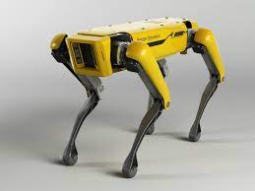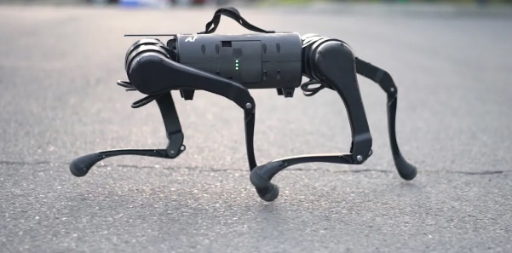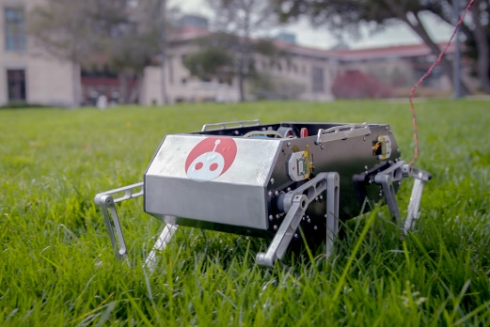

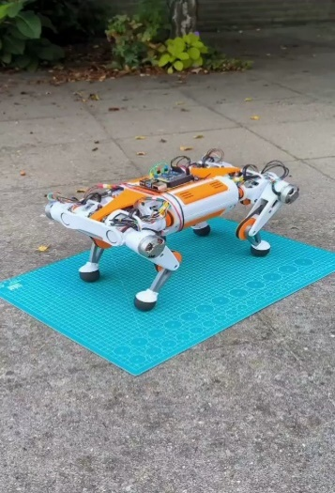

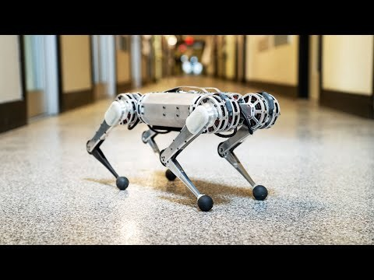

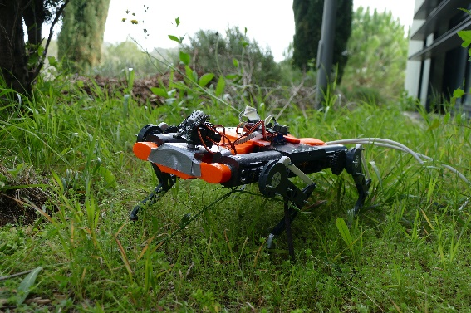

**Student:**

Hugo DURAND

**Year Manager:**

Pascal MASSON

Guillaume DUCARD

**SUMMARY**

Table of contents

Preface3

**Introduction3**

**Problematic and Robot choice4**

**Inspiration and Examples4**

**Requirement specifications4**

**Gantt diagram4**

**Building body5**

Materials2

Leg modelling2

Body structure2

**Electronic component5**

JN30D-Nano Card2

Motor2

Driver / Servo controller2

Power supply / Battery2

**Software**3

Sources used6

**Preface**

**Introduction**

The robotics program at the Polytechnic University of Nice Sophia trains engineers capable of mastering the design stages of an autonomous robotic system. An autonomous system is one that can achieve a given set of goals in a changing environment—gathering information about the environment and working for an extended period of time without human control or intervention (*BlackBerry QNX definition*). Autonomous robots can be used to improve the speed and accuracy of routine operations, particularly in warehousing and manufacturing spaces; work side-by-side with humans for added efficiency; and reduce the risk of employee injury in dangerous environments.

The objective is thus to create a robotized system with the JN30D-Nano (NVIDIA) supervised

by Mr MASSON and Mr DUCARD, two teacher-researcher. We have some manufacturing constraints. We have a size limit of 20 cm x 40 cm x 30 cm under penalty of devoting an excessive amount of time to the realization of the mechanical parts and for concerns of transport. Finally, we have a limited common university budget. We have to choose electronic components and materials that are not too expensive, while meeting the design needs of the robot.

A year ago, as part of the Electronics-Arduino course in the preparatory cycle, I had the opportunity to build a dog robot from scratch. I spent a lot of my free time working on the construction of the body, the gearing for the movement of a leg, and more particularly on the hardware and software. Raphaël ANJOU, my associate for the project, and I, took time to understand the power requirements of the motors, the importance of a good controller card. After two or three tries of cards, the SSC32 servo controller card worked like a charm. We also learned how to work on PlateformIO to build a well-structured algorithm using several classes and functions in C++. We also learned how to work on PlateformIO to build a well-structured algorithm using several classes and functions in C++. This is very useful, especially to be able to configure a specific electronic environment on which to upload the code to the Arduino UNO board. In the end, our robot had difficulty to move because of its heavy weight compared to the strength of the motors, or probably because of the low efficiency of the gears to maintain the initial torque of the servo motors. So, we identified possible improvements we could make to a second version of the dog robot and went on to do so. We rebuilt the body this time out of aluminium instead of a 3D printed plastic body (which was deemed fragile and not suitable for the purpose). In addition, we opted for 1.4x larger legs (more powerful to lift the body), a herringbone gearing (avoiding unintentional degrees of freedom) and using 35kg/cm servo motors instead of 13kg/cm.

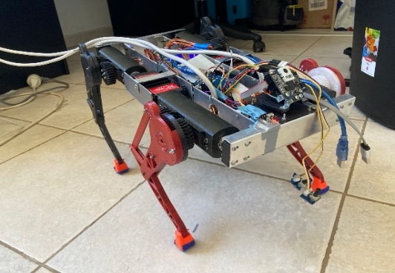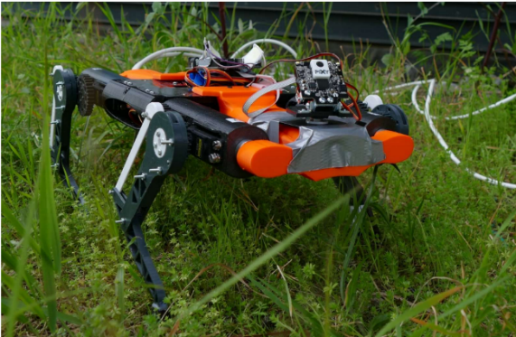

PolyDog_version1 (fully 3D printed) PolyDog_version2 (aluminium body)

**Problematic and Robot Choice**

Our problem is to build an autonomous robot that responds to a mission in the field of agriculture, surveillance, delivery or cleaning.

Some of the class opted for a robot that plants in arid areas, a robot that cleans boat hulls or a robot that maintains vineyards. Others chose to go for a biomimetic robot, such as a snake or a spider. To do cartography, a pair of people want to build a submarine.

For my part, I don't have a particular mission in mind. I want to continue what we started with the dog robot with Raphael. As we can see from people and animals, legged locomotion has the potential to handle rough terrain better than any other locomotion types. It can be used in many situations where the presence of man can be avoided, either in the case of tiring or repetitive work, or dangerous work. A very simple example, SYDNEY ZOO uses Unitree A1 robot dogs for monitoring cheetahs.

However, legged locomotion requires complex leg mechanism, high power density actuators and advanced control methods, which have prevented the widespread use of legged robots for a long time. In addition, our robot dog PolyDog is not conclusive until now and I refuse to move on to another project before I can achieve what I set out to do. These are the reasons why I want to continue with a robot dog by bringing him in a first time even more solid mechanical parts and more powerful electronic components. Then, once the mechanical construction is completed. I would be able to concentrate on the walking of the robot, how it moves with a more uneven terrain.

**Building Body**

**Material**

**Leg Modelling**

Moving the knee with a chain, with a gear to keep the motors close to the body.

When modelling the leg, you have to think about the location of the motors, the structure of the different parts, i.e. the length, the shape, etc. This is essential to optimise the mechanical transmission of the motors to the movement of the leg. I'm going to start with the location of the engines because at the beginning with Raphael, we particularly focused on that.

After seeing some examples of robot, we saw that for an optimization of the movement, to keep a light leg, it is necessary to keep the motors centralized at the level of the robot body.

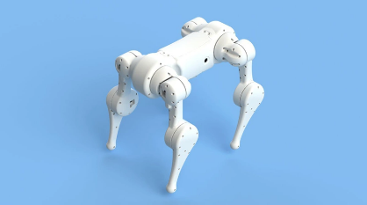

Spot mini Dizzy wolf

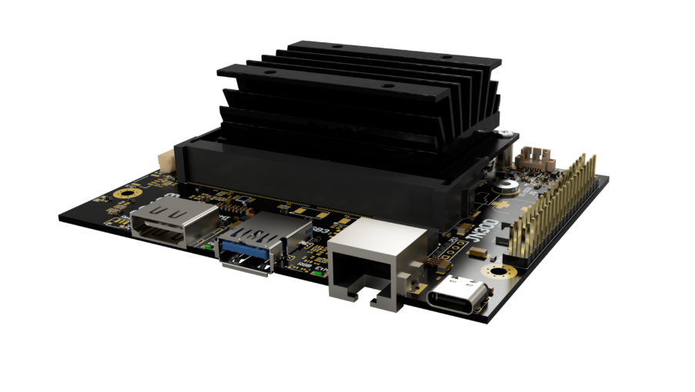

**JN30D-Nano Card**

We do not have to choose the central brain card. We will use the JN30D-Nano Card for our robot project. I've read up on the Internet and have a small overview of the specifications of this card.

Auvidea JN30 Carrier Boards are designed to convert the Jetson™ Nano™ compute module into a super mini computer. The JN30D features an industrial strength design and is commercially deployable in any volume. These systems let you dive into AI with ease. They allow you to explore AI applications like people detection, face masking and more.

* 128 GB SSD includes: Linux, Jetpack 4.6, SDKs (VisionWorks, DeepStream and more)
* requires Linux host PC and Internet connection to initially flash the system and install the software
* a large variety of add on modules available from Auvidea
* industrial strength design

Power 6V - 19V (5.5/2.5mm connector)

**Brush servo motor**

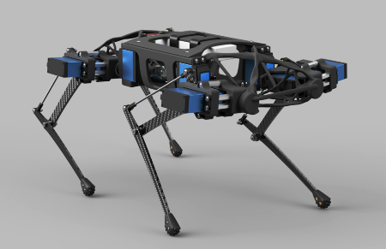Brush servo motors feature simple two wire control, easy installation & operation, and low cost. Brush Servo Motors can operate in extreme environments due to a lack of electronics, usually have replaceable brushes for extended life, and do not require a controller when operating at a fixed velocity.

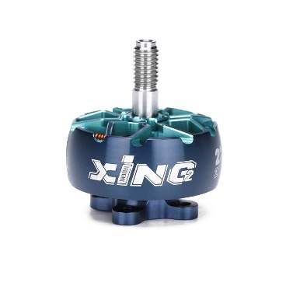This walking Quadruped Robot DIY has twelve Servo, SPT5435LV-180 with a torque of 35kg/cm. This is a video of how this robot move: <https://www.youtube.com/watch?v=Y6QYdh4bs70>. These servo motors are large torque metal gear digital servo. We used this kind of servo motor for our robot, with the same torque. We have not reached the same level of agility. I think this is due to the fact that it is much lighter and we did not focus on training the robot on software. Indeed, we just chose angles that described the movement of the legs best to our eyes.In this video, you can get an idea of what it looks like <https://www.youtube.com/watch?v=g1pQitycG0I>. In these examples of walking quadruped robot is quite lively in its movements, however, its gait is not precise and a bit laborious.

**Brushless servo motor**

Brushless DC (BLDC) technology has been around in one form or another for several decades. Brushless Servo Motors have windings in the stator and permanent magnets attached to the rotor. No brushes are used. Motor rotation is achieved by means of electrical commutation performed by the servo drive. According to Warren Osak, Founder & CEO of two Industrial Automation Distribution companies specializing in Robotics and Factory Automation, Brushless servo motors provide high acceleration, high torque, and no maintenance. Brushless Servo Motors offer the highest torque-to-weight ratio and are commonly used in the highest throughput, precision, and demanding applications. Most of the dog robots that have been created use brushless motors. They come in all price ranges. Le robot Doggo de Standford utilise des T-motor 5212 KV340 ($109.90), Xdog, des BE8108 8108 brushless motor ($100) and Dogger from Ultra Robotics use Tarot TL68P07 6S 380KV 4108 Multi Rotor ($38).

There are also gimbal motors. A gimbal motor is a 3-phase brushless motor whose stator is wound with many turns, and as such exhibits much larger resistance and inductance compared to the high-current brushless motors used to provide lift to drones, rc planes etc. Gimbal motors are used in… well… camera gimbals mainly, because they offer smooth motion and require small currents to produce torque compared to the ‘regular’ brushless motors. This in turn can help minimize the size of the motor driver and associated wires.

**How to choose the right brushless motor**

Then to choose the right

brushless motor, you must look at several characteristics: weight, size, constant motor velocity (Kv) or rotation per minute (RPM) which is related by the relation V x Kv = RPM, maximum thrust and motor resistance.

Enabling Gimbal Mode

Warning

* Although tested, gimbal mode is still experimental. Please ensure all safety precautions, and use at your own risk!
* DO NOT perform calibration on a gimbal motor without setting gimbal mode first! There is a risk of damaging the motor and board.
* Using arbitrary resistance and inductance settings can damage your motor and board.

**Power supply unit / Battery**

The choice of battery or power supply unit depends on the motors chosen.

The most popular solution in industrial arms is a force/torque sensor mounted between a robot tip and a gripper. It’s a multi-directional strain gauge which gives us data about forces affecting the gripper.

<https://www.google.com/search?q=iflight+motor&rlz=1C1VDKB_frFR988FR988&oq=motor+ifli&aqs=chrome.1.69i57j0i22i30l3.4514j0j7&sourceid=chrome&ie=UTF-8>

The motor itself is listed in the paper as an iFlight ex-8 (they also mention another motor called the T-motor U8). The paper said the iFlight motor was about $66 but I couldn't find one that cheap (maybe because they bought in bulk?). They also have a 6:1 planetary reduction to achieve the torque for the robot. Hopefully that helps you out enough as that's about as much as I can get from the paper.

Source used

Définition autonomous system :

<https://blackberry.qnx.com/en/ultimate-guides/autonomous-systems>

<https://www2.deloitte.com/content/dam/Deloitte/us/Documents/manufacturing/us-manufacturing-autonomous-robots-supply-chain-innovation.pdf>

Brush servo motor vs brushless motor:

<https://www.linkedin.com/pulse/brush-servo-motor-vs-brushless-which-better-my-application-osak/>

<https://www.alliedmotion.com/brushless-motors-whats-the-big-difference/>

Gimbal motor

<https://tinymovr.readthedocs.io/en/latest/hardware/gimbal.html>

How to choose the right brushless motor;

<https://www.dronement-drone.fr/article/tout-savoir-sur-les-Kv>

* Dragon Skin 30 for feet
* T-Motor MN5212 KV340 High-Performance Brushless Electric Motor for Multi-Rotor Aircraft
* Fibre de carbone au lieu de l’alu : **La fibre de carbone est un matériau qui offre une rigidité et une résistance à faible densité** - qui est plus léger que l'aluminium et l'acier, ce qui procure de nombreux avantages pratiques.

Poids pour le poids, **la fibre de carbone offre 2 à 5 fois plus de rigidité** (selon la fibre utilisée) **que l'aluminium et l'acier** . Dans le cas de composants spécifiques qui ne seront sollicités que le long d'un plan, en fibre de carbone unidirectionnelle, sa rigidité sera de **5** à **10 fois supérieure à celle de l'acier ou de l'aluminium** (de même poids).

http://fr.custom-composite.com/info/aluminium-vs-carbon-fiber-comparison-of-materi-25728106.html

!!!! ODrive already has PID control loops build in for controlling position, velocity and torque of the motor.

* EM-356A-SBL BRUSHLESS DC-MOTOR DRIVER 12-24V 15/20A another solution,
* I think it will be better to have metal component on the articulation of the robot.